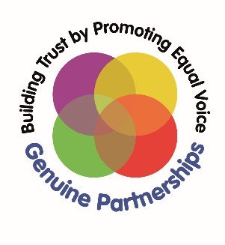

Quality Indicators for Co-production and Inclusive Practice

Everybody’s business

Introduction

Good quality co-production and participation is required by the Children and Families Act 2014 and subsequent SEND legislation. However, this process and its success depends on organisational cultures fostering and embedding this approach.

These Quality Indicators have been produced to help groups, organisations and partnerships identify and develop good practice in how they work together in co-production.

Evidence shows that when local area partners actively work towards these Quality Indicators together, a culture of inclusion and co-production begins to thrive, trust strengthens, relationships flourish and better outcomes are generated for all.

What is co-production and inclusion?

Co-production is an equal and reciprocal relationship where everyone’s knowledge and skills are used to create better outcomes.

Inclusion is a universal human right that is about embracing all people, irrespective of race, gender, disability or other attribute which can be perceived as different.

About this document

This document sets out a Quality Indicators action-planning and evaluation framework.

These Quality Indicators draw on the four principles of co-production. These principles were developed by Rotherham parent carers, young people and families through Alliance member Genuine Partnerships. The framework was devised in partnership with Contact.

The four principles required to create a good quality of co-production and inclusion are:

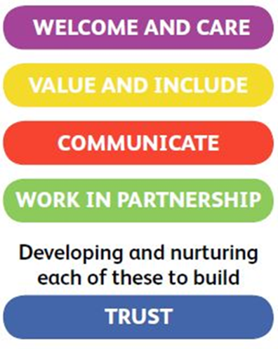

Using the Quality Indicators

Step 1: Reflect on and discuss each Quality Indicator and consider how the principles of co-production:

- feature in your vision/mission statement
- are modelled and promoted by leaders
- are included within your strategic plan
- are evident in your organisational values
- impact on organisational processes and methodology
- are embedded in recruitment processes
- determine joint decision-making
- are reflected in commissioning criteria
- are integrated in your Local Offer
- affect budgets and investments
- help shape workforce development priorities

Step 2: Consider:

- how well are you doing locally?
- what does good look like to you?
- what are your examples of best practice?
- what is happening already?
- what could be better?
- how are you thinking about these questions in co-production?
- what do you need to do next?

WELCOME & CARE

What should it feel like? | What’s going well in [your Local Area name]… | What could be better [your Local Area name]…
All voices are heard and valued  Expectations are communicated early  and with clarity  Supportive communities are built in partnership  Environments feel happy and secure  for everyone  Confidence, well-being and self-esteem  are nurtured  Strengths and achievements are  emphasised  Responses are always kind | Give examples of good practice within the Local Area from organisations, departments, services and school/settings | Give examples

10
Great

5 OK

0
Not Great
How are we doing?
[Type a quote from the document or the summary of an interesting point. You can position the text box anywhere in the document. Use the Drawing Tools tab to change the formatting of the pull quote text box.]

NEXT STEPS

What needs to happen now?

What will this involve?

How will this be done in co-production?

VALUE & INCLUDE

What should it feel like? | What’s going well in [your Local Area name]… | What could be better in [your Local Area name]…  How are we doing?
A ‘can do’ approach is the norm  Decision making processes involve  the people they are about, or affect  Needs are identified early and  involvement of all partners is  welcomed at every stage  Information about strengths and  needs are shared, with permission,  and with all who need to know  Everyone tries to have the right  knowledge, understanding and  skills to respond constructively to  different strengths and needs  - Responses to individual needs and  - changing circumstances are  - creative and flexible  - Everyone is involved in the  - development of policies, systems  - and values | Give examples of good practice within the Local Area from organisations, departments, services and school/settings | Give examples  10  Great  5  0  Not Great

NEXT STEPS

What needs to happen now?

What will this involve?

How will this be done in co-production?

COMMUNICATE

What should it feel like? | What’s going well in [your Local Area name]… | What could be better in [your Local Area name]…  How are we doing?
Views and involvement are always  sought  Listening is calm and respectful  Follow up responses are timely  and constructive  Time and space is made available  to ensure everyone’s voice is  heard in a way that suits them  Information is given in good time  and in an accessible format taking  into account individual needs  Language is positive and  constructive  Agreed actions are regularly  reviewed and evaluated with all  partners | Give examples of good practice within the Local Area from organisations, departments, services and school/settings | Give examples  10  Great  5  0  Not Great

NEXT STEPS

What needs to happen now?

What will this involve?

How will this be done in co-production?

Partnership

What should it feel like? | What’s going well in [your Local Area name]… | What could be better in [your Local Area name] …  How are we doing?
There are opportunities for all partners to feedback in order to improve everyone’s experience  Everyone is an equal partner and their contribution is valued  Co-production and participation in individual and strategic decision making is actively encouraged  Partners work well together to develop plans, set targets and create and deliver specific programmes | Give examples of good practice within the Local Area from organisations, departments, services and school/settings | Give examples  10  Great  5  0  Not Great

NEXT STEPS

What needs to happen now?

What will this involve?

How will this be done in co-production?

For further information and resources on co-production, please visit Contact’s website at www.contact.org.uk, or email Contact’s parent carer participation team at parent.participation@contact.org.uk.

To find out more about the work of Genuine Partnerships and the four principles of co-production visit www.genuinepartnerships.co.uk.

Contact 209 - 211 City Road London EC1V 1JN T: 020 7608 8700 E: info@contact.org.uk contact.org.uk
Contact is a trading name of Contact. Charity registered in England and Wales (284912) and Scotland (SC039169). Company limited by guarantee registered in England and Wales (1633333).
VAT registration GB 749 3846 82.

